# Create an Accessible Table in Brightspace

Copying and pasting tables from Word to Brightspace will break the accessibility, even if formatting is removed when pasting the table into Brightspace. The remediation options in Brightspace are confusing and do not result in an accessible table.

Instead, create the table structure in Brightspace and then copy and paste the text into each cell. This takes more time, but the results will be accessible. Follow these steps:

1. In a module in Brightspace, create a Brightspace file by clicking on Upload/Create🡪Create a File (Web Page).   
   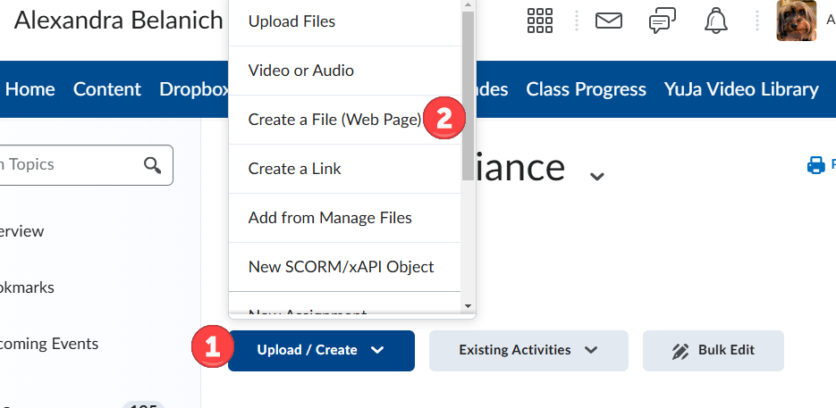
2. In the Brightspace editor (text editor) click on the Table icon to insert a table.   
   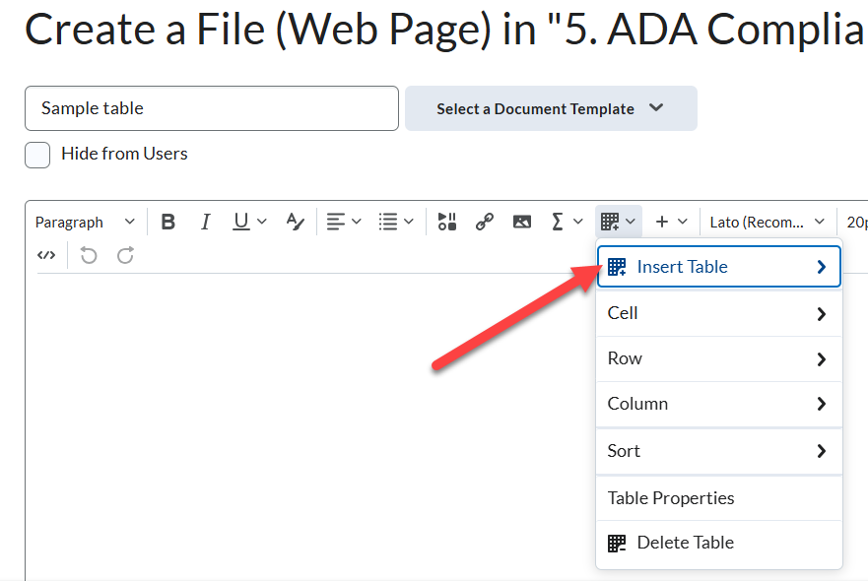
3. Click and drag to select the number of rows and columns that you want.   
   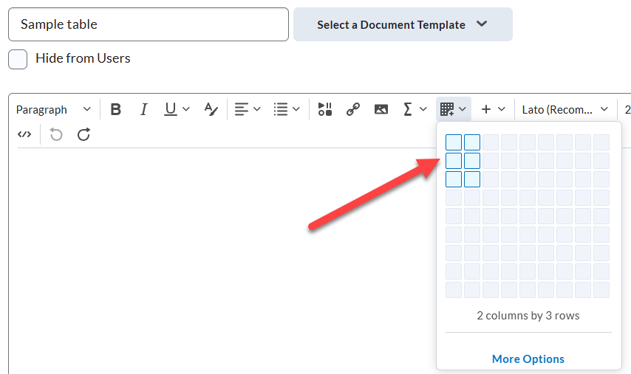
4. Now that the table has been created, type directly into the cells or copy and paste the text from your table in Word into the cells. Note: If you are copying and pasting text from Word, be sure to Paste as Plain Text.   
   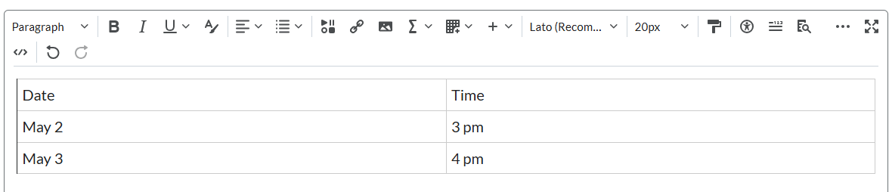
5. To designate the first row as the header row, select the top row.   
   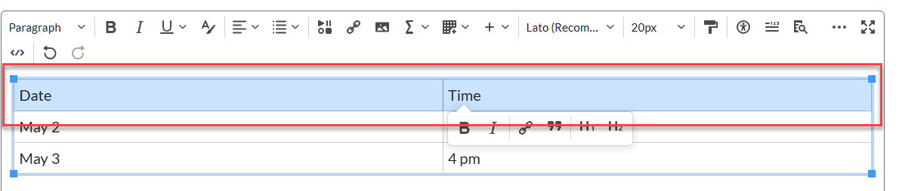
6. With the top row selected, click on the Table icon again, then click on Cell.   
   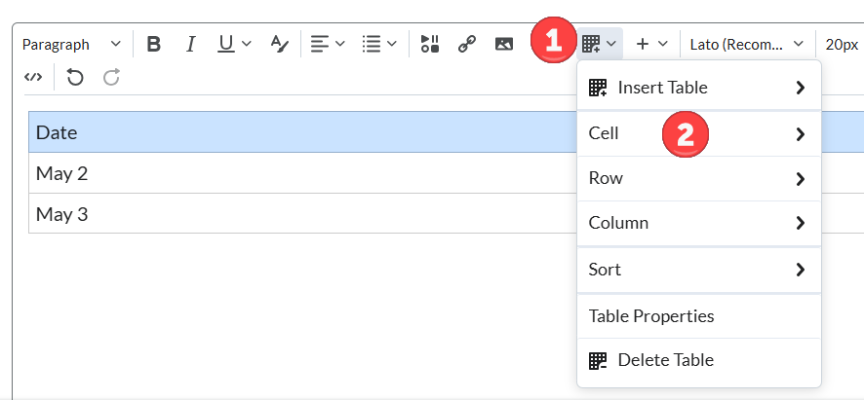
7. Then, click on Cell Properties.  
   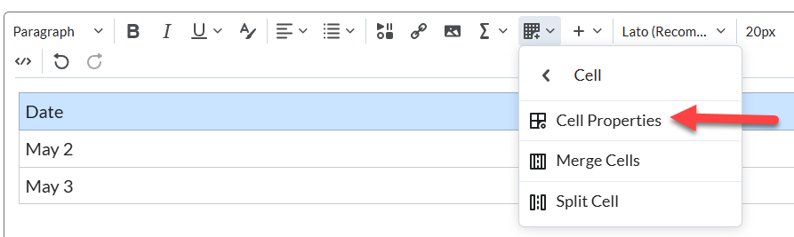
8. Under “Cell type,” click on “Header cell.”  
   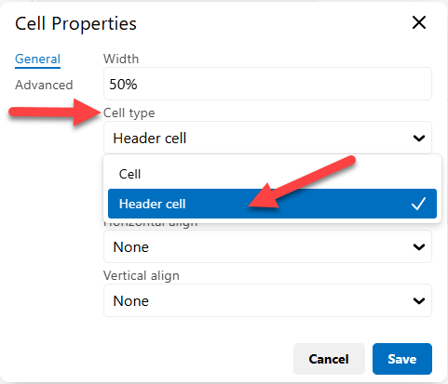
9. Under “Scope,” click on “Row.”  
   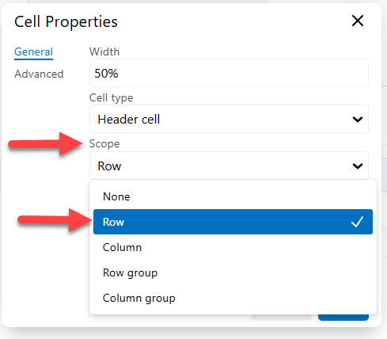
10. The selections should look like this. After this, hit Save.   
    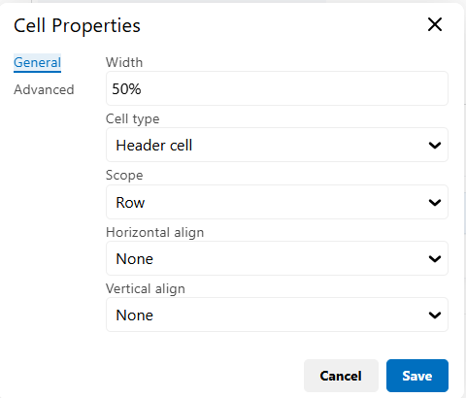
11. You are not done yet! The table still needs a caption. Click on the Table icon again and this time select “Table Properties.”  
    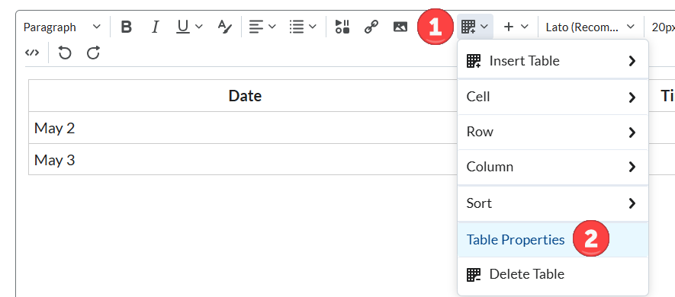
12. In Table Properties, check the box “Show caption,” then hit Save.   
    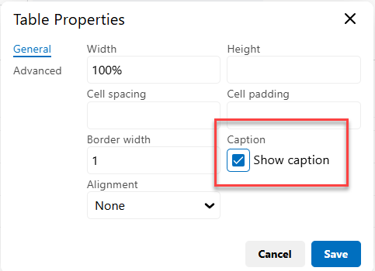
13. A caption field will appear above the table. Edit this with the title or description of the table.   
    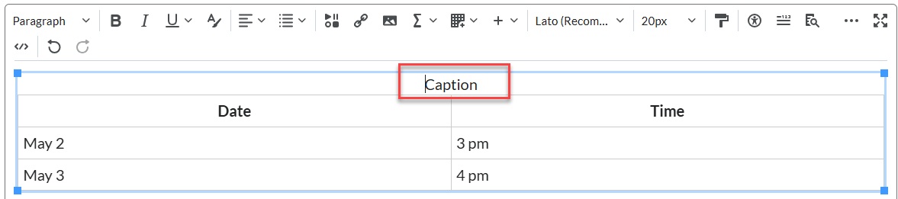
14. When you are done, click on the accessibility icon to see if the table passes the accessibility check.   
    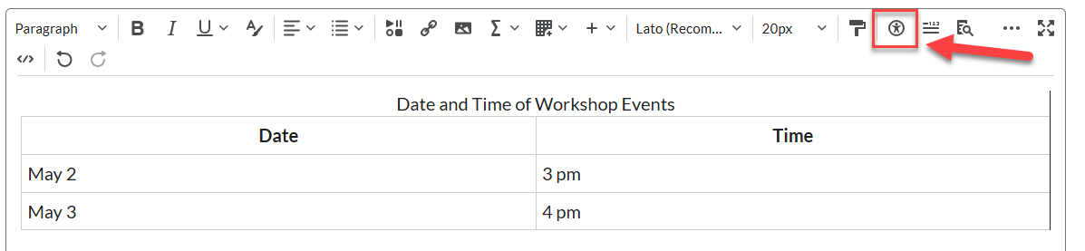
15. There should be no accessibility issues detected. Congratulations!  
    